In memory of Mr Sekona Latu
Brother Sekona Latu went to be with the Lord on 9th April 2023. He was diagnosed with cancer in early 2022 and went into palliative care in the Mt Druitt hospital at the end of March 2023. We pray for his widow Faye, and his son Paul and family, as well as his brother Lopeti, a deacon in the Mt Druitt PCEA church.
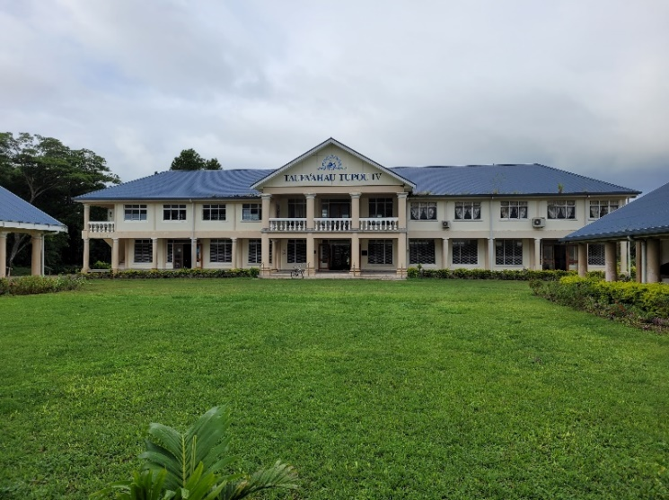
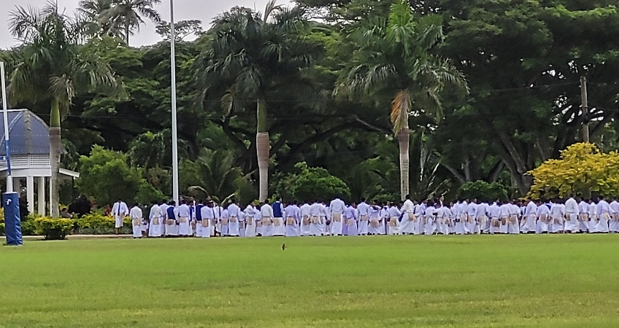
Sekona was born on the island of Ha’apai in Tonga in 1958. He graduated from Tupou College, a high school for boys on the main island of Tonga-tapu. This school was established by missionaries who brought the gospel to Tonga. Sekona loved his days at Tupou College, and it was there that his wonderful singing voice was developed. A retired teacher at the college remembers him well, writing of Sekona as ‘A small man with a big heart’. Sekona moved to Australia in 1980 where he did further studies, got married to Faye and had a son, Paul.
Sekona first came to Mt Druitt PCEA in 2010. He and Tevita, also a deacon, came looking for another place to worship after the church they were attending was sold, and they were told to go to Blacktown. Although a small church, these brothers felt warmly welcomed and appreciated the simple style of worship at PCEA Mt Druitt. They returned with 6-8 other Tongan families to make this church their home.
Sekona was very musical and quickly learnt the tunes put to the metrical psalms sung in PCEA worship. He was soon leading the ‘a capella’ singing; he gathered the Tongan members each Saturday night to teach them the tunes. He also gathered the youth on Friday nights to teach them singing and share the word of God. Sekona was always at the church early to help with opening up, and setting things up for communion. He was a willing worker in keeping the grounds of the church, and in general maintenance.
Sekona attended evening, as well as morning worship, with his wife. In addition to leading the singing he was often called upon to preach the word when the minister was away. In 2014, just four years after becoming a member Sekona was inducted as an elder into the PCEA. He continued as a faithful servant leader until 2019 when he and Faye left the church. But the elders of the church and others kept in touch and visited Sekona when they learned of his illness.
We remember Sekona with words of Scripture he gave to his wife as he breathed his last in this world. He read from Philippians 4 urging her to continue strong in the Lord; ‘I can do all things through Christ who strengthens me’. He could have said, as the apostle Paul said in verse 9: ‘The things you have learned and received and heard and saw in me, these do, and the God of peace will be with you’.
We give thanks to the Lord for the life and service of this brother in Christ, and pray for the family he has left behind on this earth. May they, and all who knew Sekona, be looking forward to being with him in the presence of the Lord for eternity.

