The Voice dkm Jan/Feb 2023
It appears that we will soon have a referendum asking us to amend the constitution to include ‘a voice’ to the parliament, presumably a voice for the indigenous people of Australia. Just what this ‘voice’ will include we have not been told, and it seems will not be told. Indigenous people get to vote like every other citizen of Australia, and for many years we have had elected representatives from their community sit in the houses of parliament.
We already have a voice included in the constitution, or the preamble to the constitution, which states, ‘Humbly relying on Almighty God’. We also have the Lord’s Prayer being said at each sitting of our parliament. The only voice we need is that of almighty God, the creator and judge of all people, all races and tribes and tongues. God, as he has revealed himself in the creation and in the Bible, is not racist or sexist or any other way discriminatory, except between good and evil, between the righteous and the wicked. It is man, sinful man that looks at the outward appearance and makes judgments; God looks on the heart.
In regard to the voice of God, we could take a look at Psalm 29 in which over half the verses refer to ‘the voice of the Lord’. David tells us to ‘Worship the Lord in the beauty of holiness’, to ‘Give unto the Lord glory and strength’. Almighty God is the all-powerful God. He does not reply upon numbers as the politicians do. He does not need a voice in our constitution because, as this psalm says, God’s voice is heard each and every day of our lives. ‘The voice of the Lord is over the waters’, which appears to mean his voice is in the storms he sends upon the earth.
Thunder and lightning can be very scary, and rightly so. ‘The voice of the Lord divides the flames of fire’, and ‘the voice of the Lord breaks the cedars’. I have seen a huge gum tree split in half by lightning. You may die if you get struck by lightning. We know that lightning strikes start bushfires, so many of our devastating bushfire are indirectly the voice of the Lord.

Of late we have seen torrential rain causing catastrophic floods because, ‘the voice of the Lord is over the waters’. We are thankful that very few have lost their lives in these floods, but the destruction of property and infrastructure has been terrible. Is this not a case of, ‘the Lord shakes the wilderness’, and ‘strips the forests bare’.
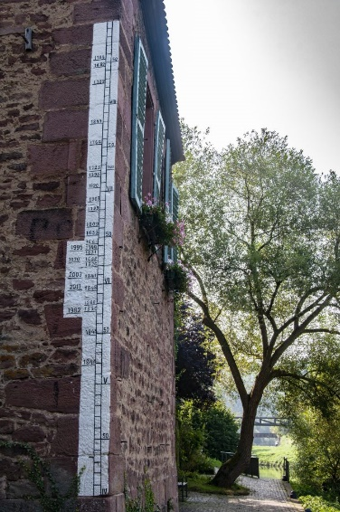
My grandmother’s house was near the river and got flooded regularly- the flood of 1959 was the highest mark on the wall as I remember. In central Europe we saw ‘flood marks’ going back hundreds of years- the highest was 1342 as I recall. In these towns built on the banks of the river, some by the Romans, we entered houses on the first floor because the road had been built up this high to avoid floods.
Very early in the Bible we read about the world-wide flood of Noah’s day. The Lord sent this flood as a judgment upon the wicked. The Lord saved Noah and his family through this flood, and promised never to flood the whole earth again. But he did not say he would not send local floods to remind people of his almighty power. Floods and earthquakes represent the Lord shaking the earth. Wise people will see the hand of the Lord in such events and humble themselves before him.
In this psalm David concludes, ‘The Lord sat enthroned above the flood’, and you would be wise to draw the same conclusion after being affected by, or seeing, a catastrophic event. Property can be replaced. Give thanks that you still have life, but remember you will die one day and you will meet your Maker. Maybe you will be questioned as to why you did not listen to the voice of the Lord over the waters, or recorded in his word, the Bible.

