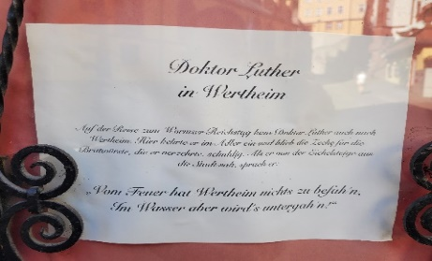
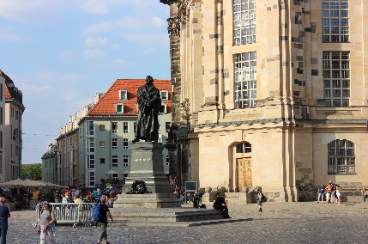
Luther and Reformation Day dkm Oct 2022
Our recent trip to Europe, and Germany in particular, did not take us to Wittenberg, the home town of Martin Luther, but we did come across his name in the town of Wertheim, and a statue of Luther in Dresden. We visited places that Luther visited especially churches and monasteries from which bishops and priests of the Roman Catholic Church and Holy Roman Empire ruled the people. I am sure Luther became disgusted and ‘suffocated’ by the grotesque icons and relics adorning these places of worship, even though he had grown up with such idolatry. We rightly celebrate the time when the Lord opened his eyes to the truth of salvation by grace alone through faith alone.
On October 31st in 1517 Martin Luther nailed his 95 theses to the door of the Castle Church in Wittenberg, Germany. It was the eve of All Saints Day when relics were displayed and people came out to offer their indulgences. In posting his theses, Luther was calling for a debate on this practice of indulgences. The Pope instituted this practice during the crusades; it proved a good way of raising money. So in 1510 when in need of funds to build St Peter’s Basilica and the Sistine Chapel, Pope Leo X re-instituted the practice. The Pope as ‘head of the church and Vicar of Christ’ promised reduced time in purgatory for loved ones when money was put into these indulgence boxes; ‘As soon as the coin in the coffer rings, the soul from purgatory springs’. But Luther questioned the Pope’s jurisdiction over purgatory, saying that if he has such power why does he not, in the name of love, let everyone out and abolish it.
Luther lived in a day when God was portrayed as more wrathful than loving. He lived in a day when the Pope, through the Church, ruled in the realms of religion and politics. Luther saw God as a tyrant who had to be appeased. In entering the monastery he became a keen student, regular in prayers, fasting and the mass. The church was his way of salvation. But his spirit was troubled. He was afraid to perform the mass because, as a re-enactment of the sacrifice of Calvary, he feared at seeing God in human form.
Luther felt unworthy, burdened by sin. He was a good monk, declaring, ‘if ever a monk got to heaven by his monkery it was I’. But this striving to balance out his sins was not giving him peace. The church was teaching that merits could be transferred in an indulgence. So Luther took to visiting the relics of the saints to get such indulgences. Rome had the greatest storehouse of relics so he went to ‘holy Rome’ in 1510. But he was disillusioned at the ignorance and irreverence of many priests. He returned doubting the whole matter of the transfer of merits.
The way of good works could not save him. Availing the merits of the saints could not save him. Luther was left with no assurance. He kept on confessing, up to six hours a day in prayer, but never sure he had confessed every last sin. He came to realise man’s whole nature is corrupt. Luther tried the way of mysticism, focussing on the love of God in an effort to find peace, but still his sin, his corrupt nature was not dealt with. Finally, Luther turned to the Bible; he had been appointed to teach Bible in 1513. He looked at the cross of Christ in a new way, seeing the rejection and suffering of Christ. The cross did not show God to be a harsh tyrant, although he must be just.
Luther studied the apostle Paul who appeared to have a solution to the problem he had with justice and salvation. Luther wrote, “I greatly longed to understand Paul’s epistle to the Romans and nothing stood in my way but that one expression, ‘the justice of God’, because I took it to mean that justice whereby God is just and deals justly in punishing the unjust. My situation was that, although an impeccable monk, I stood before God as a sinner troubled in conscience, and I had no confidence that my merit would assuage him. Therefore I did not love a just and angry God, but rather hated and murmured against him. Yet I clung to the dear Paul and had a great yearning to know what he meant. Night and day I pondered until I saw the connection between the justice of God and the statement that, ‘the just shall live by his faith’. Then I grasped that the justice of God is that righteousness by which through grace and sheer mercy God justifies us through faith. Thereupon I felt myself to be reborn and to have gone through open doors into paradise. The whole Scripture took on a new meaning.
From the Bible Luther learned that the cross of Christ is about God’s justice and the justification of sinners, justification by grace through faith. Luther no longer took instructions from the Pope but from the Bible. In the protracted doctrinal debates and court appearances he had with the Pope’s men, Luther always asked, ’What do the Scriptures say?’

