Stand on the Rock dkm Oct 2020
I often get phone calls asking for donations to a cancer foundation or some other charity. The caller on the phone today wanted money for an organisation stamping out bullying in schools. She told me how serious this problem was, with one in four kids experiencing bullying. Before she got to asking for money I asked what was her answer to this problem. I suggested that telling kids about Jesus and his love is the best way to stop bullying and help kids find hope and love in their lives. I did not question her sincerity, although we have had the infamous ‘Safe Schools program’ that purported to be about bullying in schools. Besides, I never give to ‘cold callers’ anyway; I am surprised that anyone does but some must because they keep calling! I fully support the work of Scripture in schools, and the Gideon’s.

Have you noticed that at least one story in the nightly news is followed by the words, ‘If you are disturbed by this story you can call Lifeline or Beyond Blue’? Why is this? Why are these organisations being swamped with calls for help? They help many people, but for how long? When someone calls in saying they are discouraged, depressed, or desperate, they listen and counsel them. But is it not better that they receive counsel from the chief counsellor found in the Bible?
When I open my Gideon Bible I find a page directing me to passages of the Bible where I will find help if I am discouraged, depressed or desperate- or even suicidal. I turn to a Psalm telling me that ‘God is my refuge and strength, a very present help in time of trouble’ (Ps 95:1).

Our little grandsons sing the song, ‘Stand on the Rock, its Jesus’. This is a modern version of the old hymn, ‘On Christ the solid Rock I stand, all other ground is sinking sand’. Jesus himself tells us about the wise man building on the rock, and the foolish man building on the sand. Far too many young people are building on the sand because this is the only foundation they are being told about. Far too many older people and middle-aged people are also building on the sand because they don’t want to know about the Rock. So depression and despair is afflicting people of all ages. This ‘disease’ is being exacerbated by the current pandemic - or is it that the pandemic is only exposing the ‘soul sickness’ affecting so many in our society? Including you?

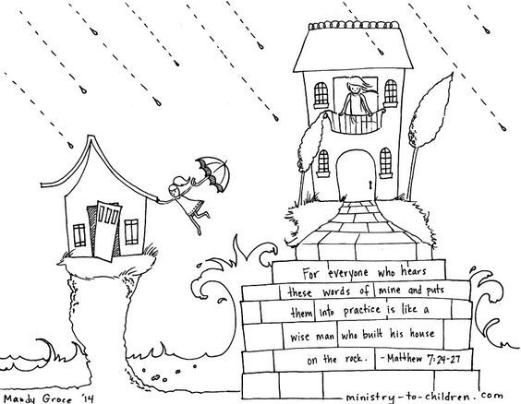
Health and economic conditions in our society may be the worst for decades, the worst since the War, but people in the Bible experienced terrible conditions also. Look at prophets like Jeremiah who saw women in his city cooking their own kids because of a siege, and then saw his city levelled (Lamentations 4:10), and look into the Psalms, as just mentioned. Men and women faced terrible deprivation and suffering but they turned to God, to the Rock of salvation who enabled them to stand when everything around them was crumbling.

Finally, look to the Rock himself, to Jesus, who suffered so terribly at the hands of cruel people. He did not suffer sickness because he has the power to heal the sick, and has the power to stop pandemics. But he suffered death; he died that you might live, and press on in the strength he gives you when you believe in him. He gives the Spirit, the Spirit of power, to all who believe. Will you turn to Jesus today and stand in him if you are lonely or have lost a loved one, if you are depressed, afraid or even suicidal? Jesus says to you, ‘Come to me all you who are weary and burdened and I will give you rest’ (Matthew 11:28). He says, ‘My peace I give to you, not as the world gives do I give you. Let not your heart be troubled, neither let it be afraid’ (John 15:27).

